# Cases Processed on Import

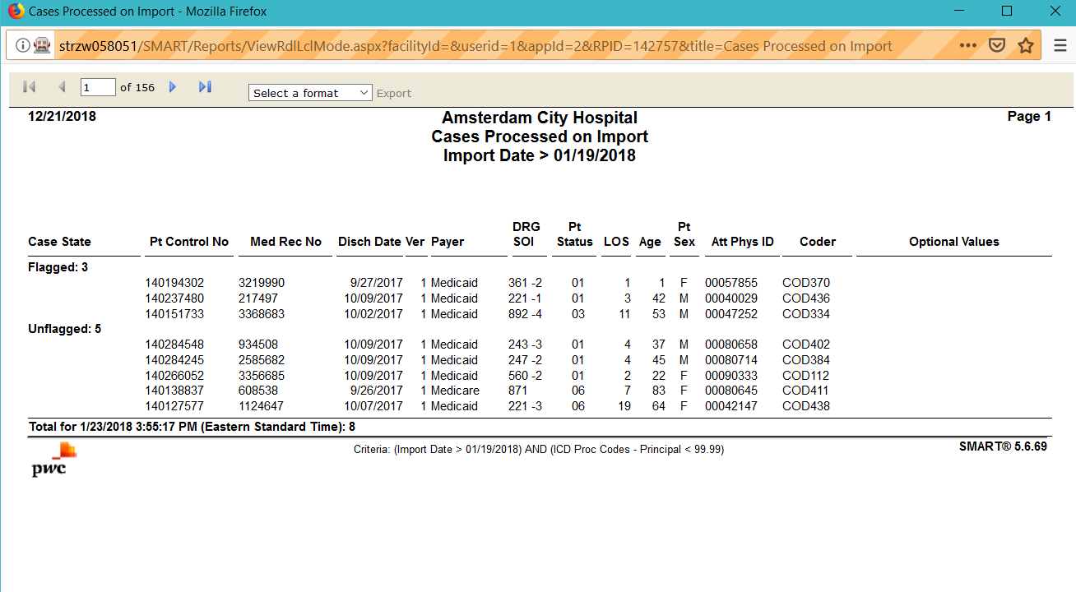

# Medicare Case-Mix by Month

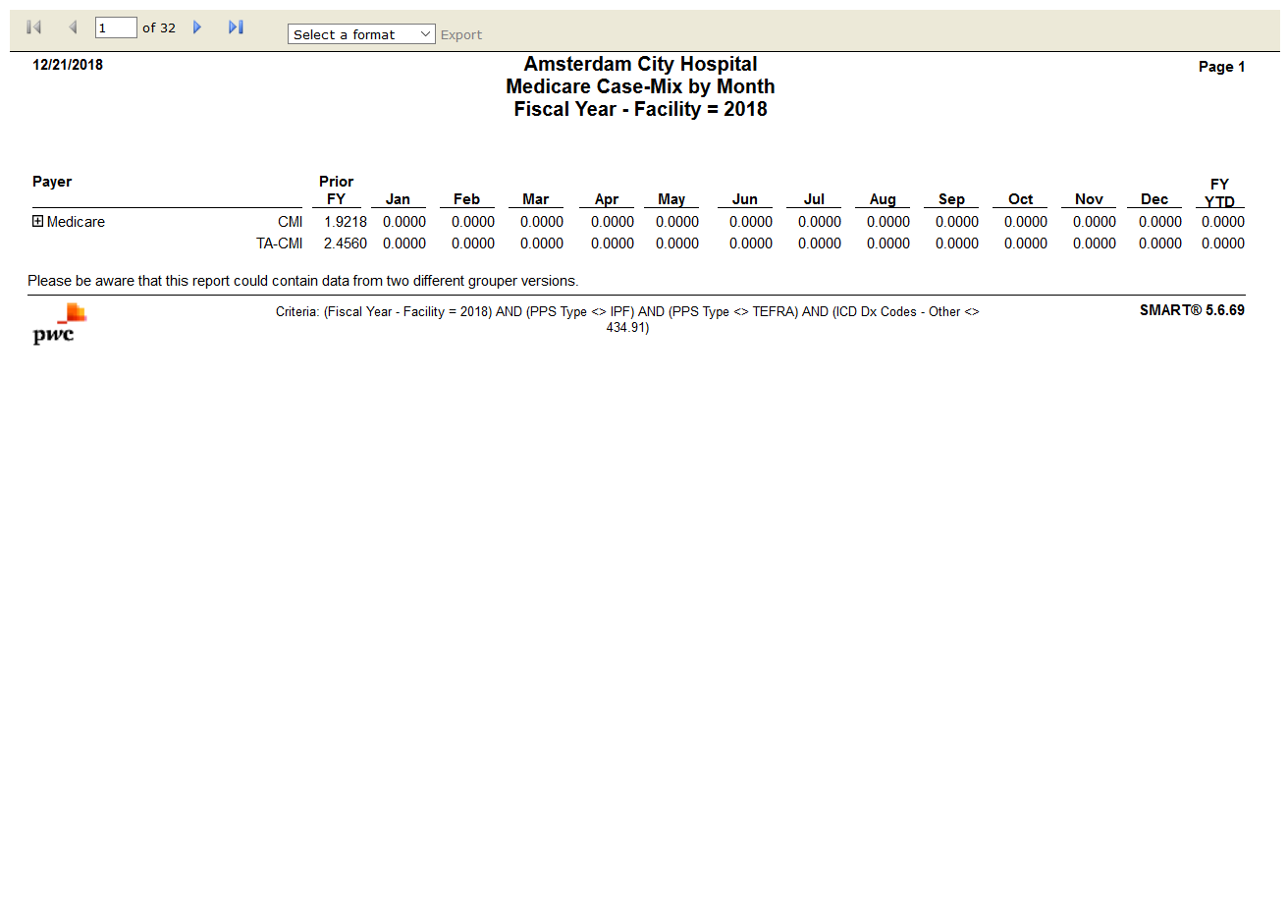

# Diagnosis Code Usage

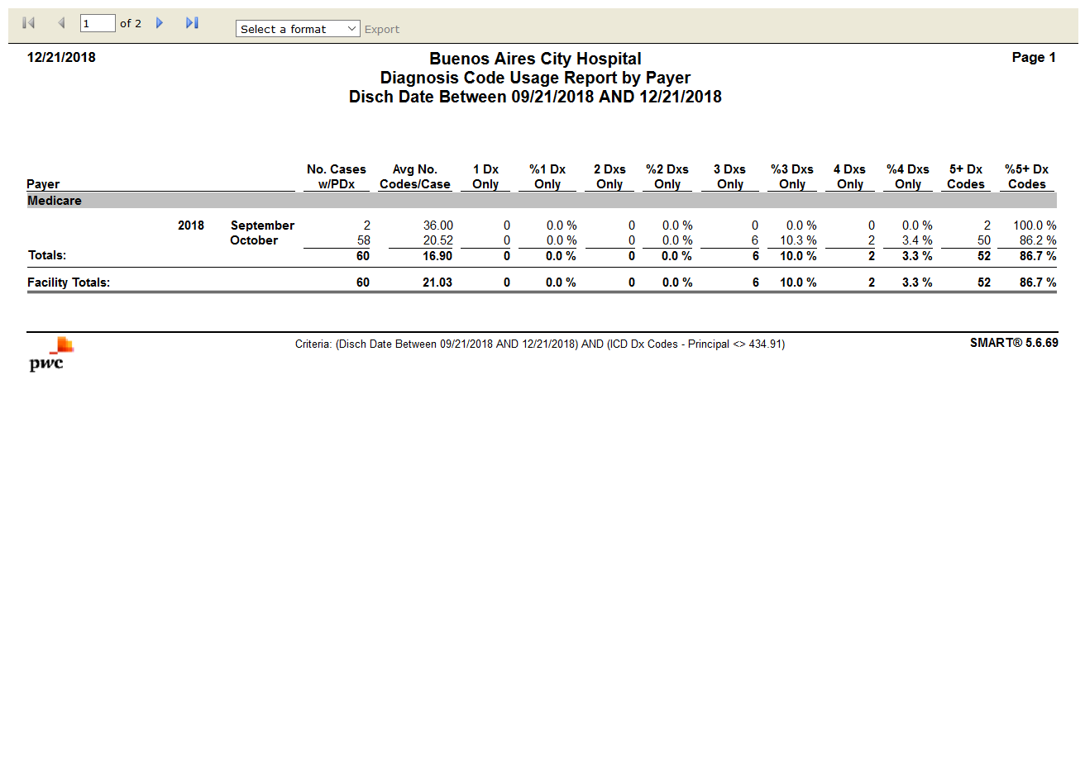

# Discharges by Grouper Version - DRG

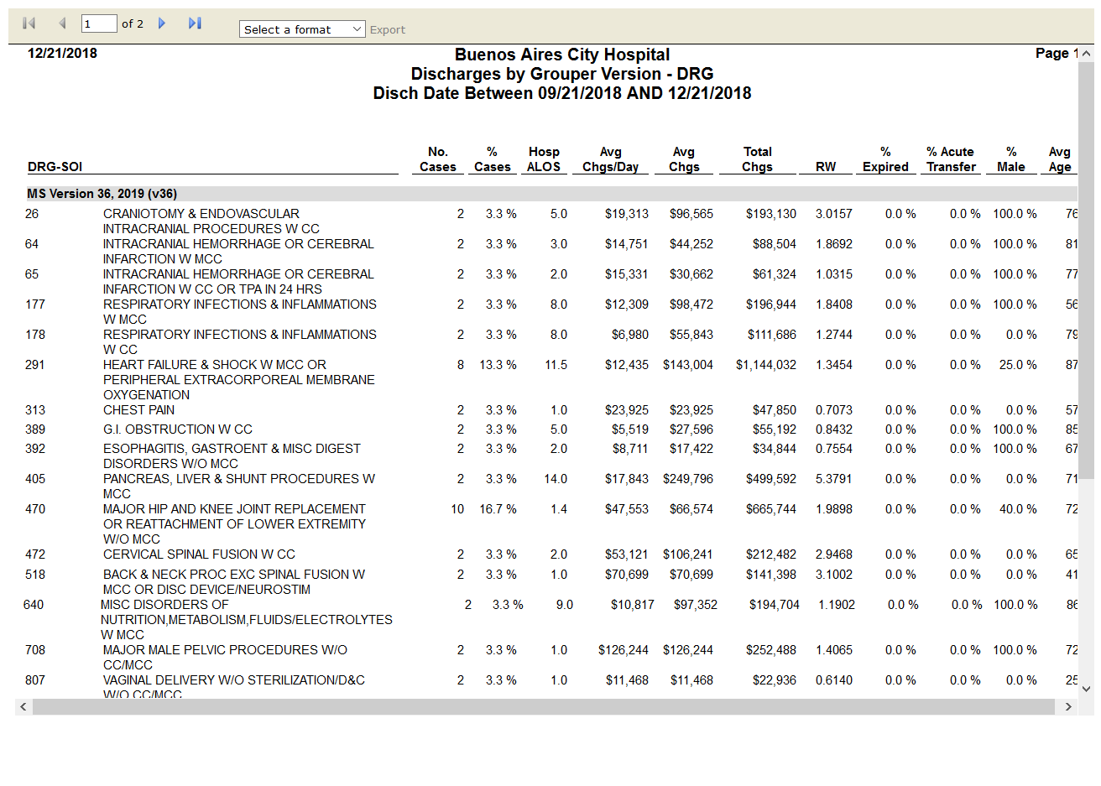

# Coding-DRG Accuracy Analysis

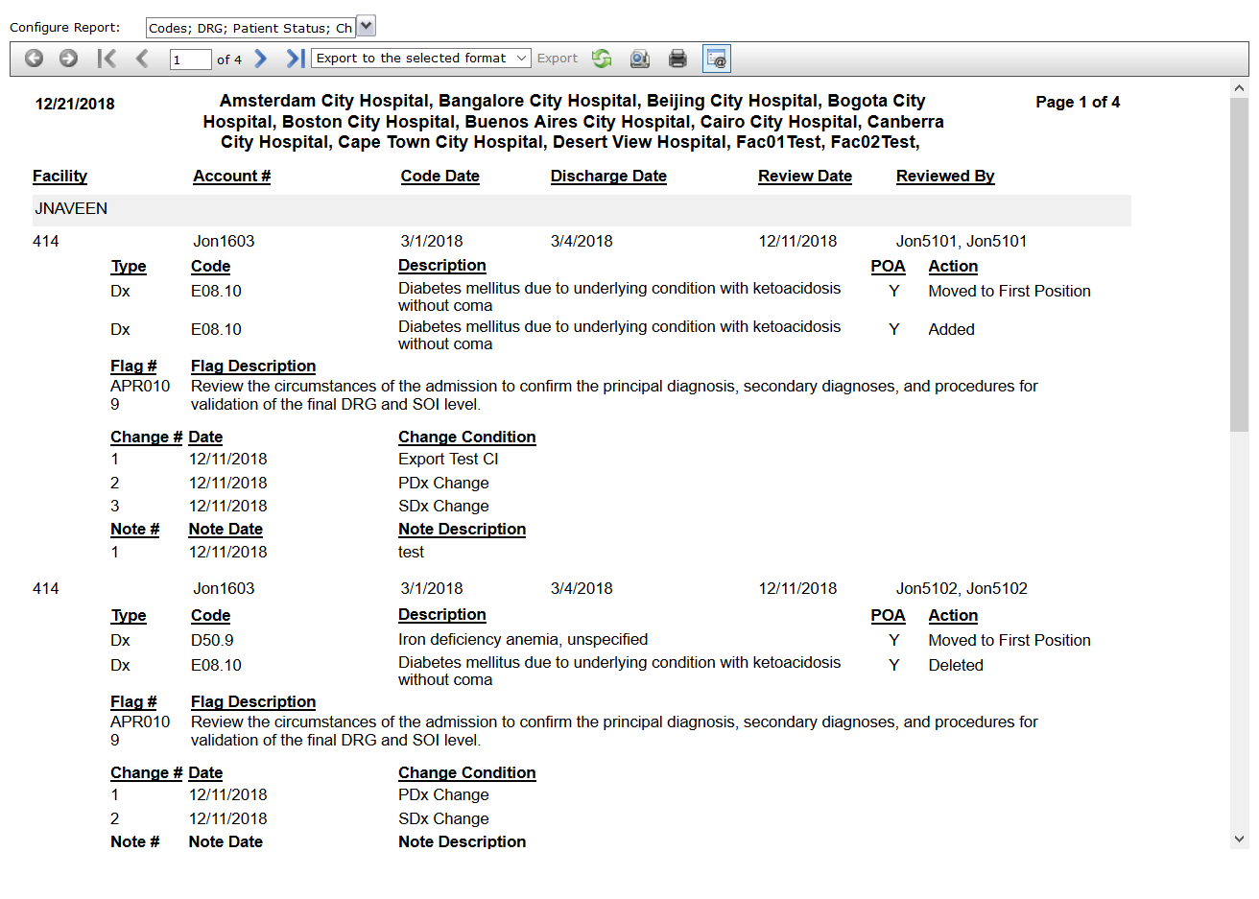

# Coding-DRG Review Summary

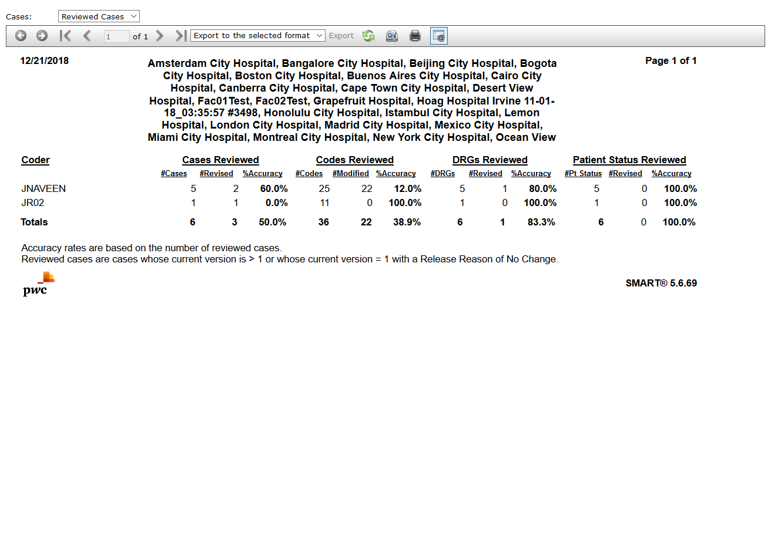

# DRG Change Condition Detail

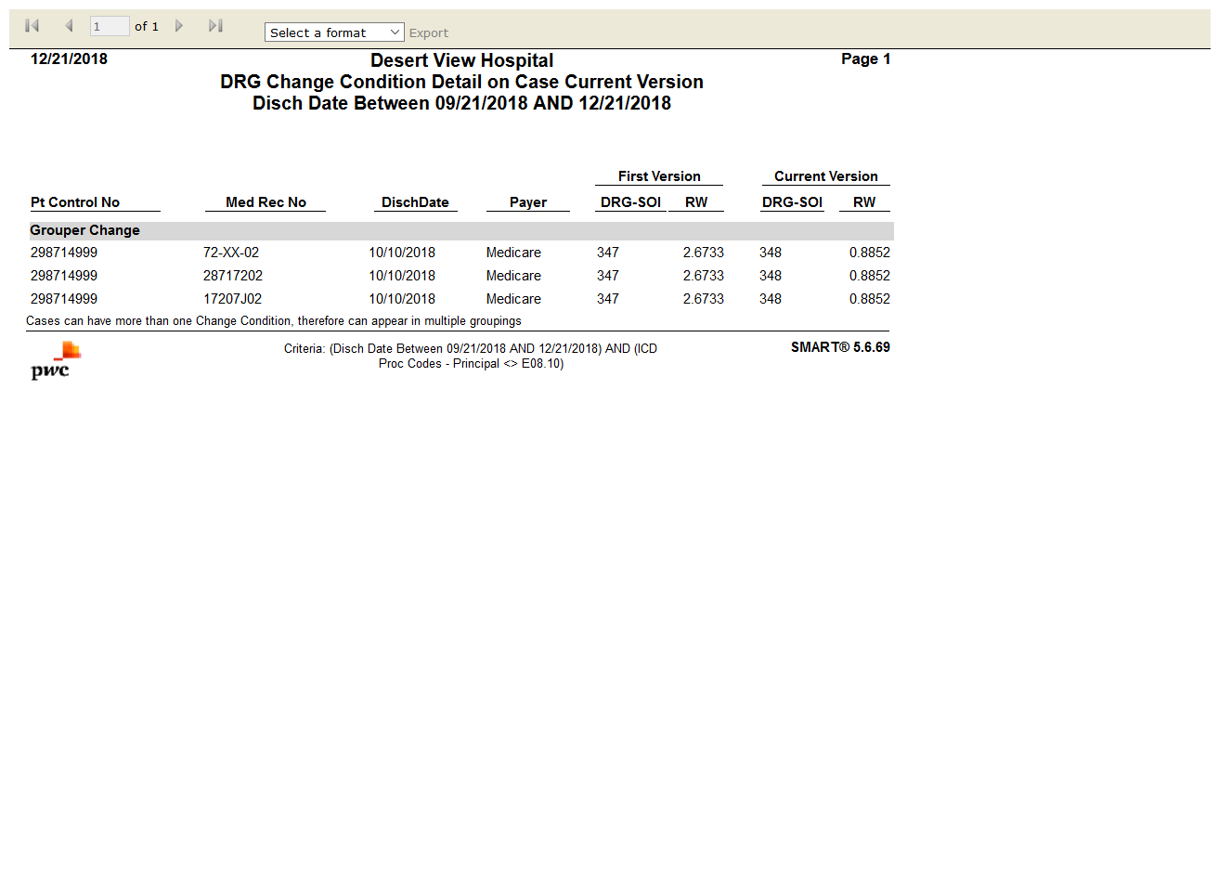

# DRG Change Impact

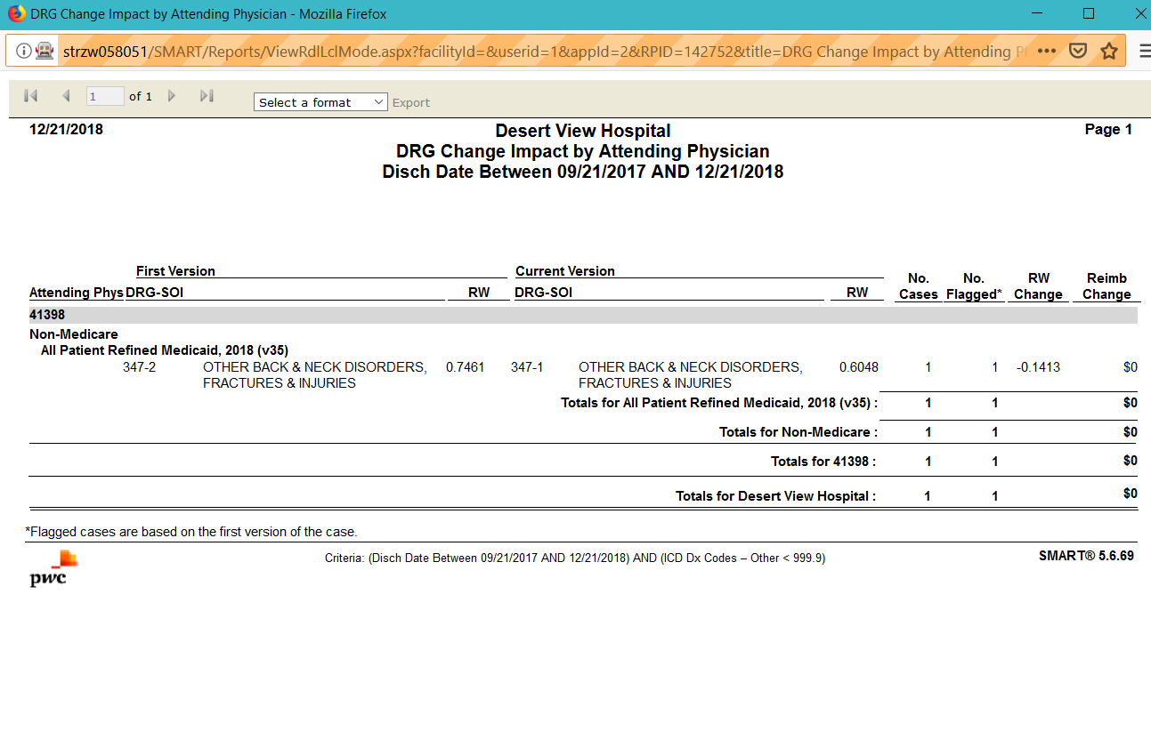

# DRG Clinical Profile

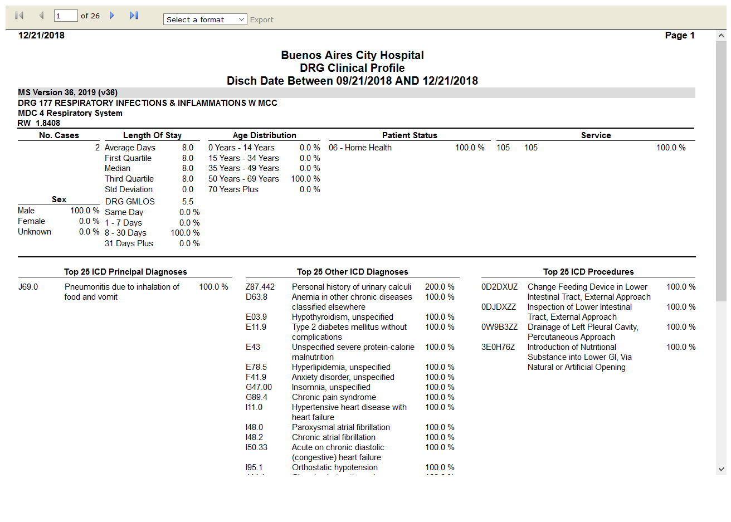

# DRG Contribution to CMI

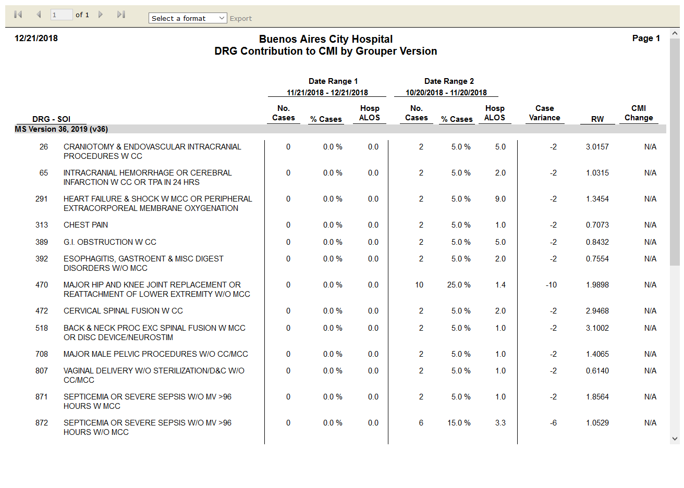

# DRG Frequency

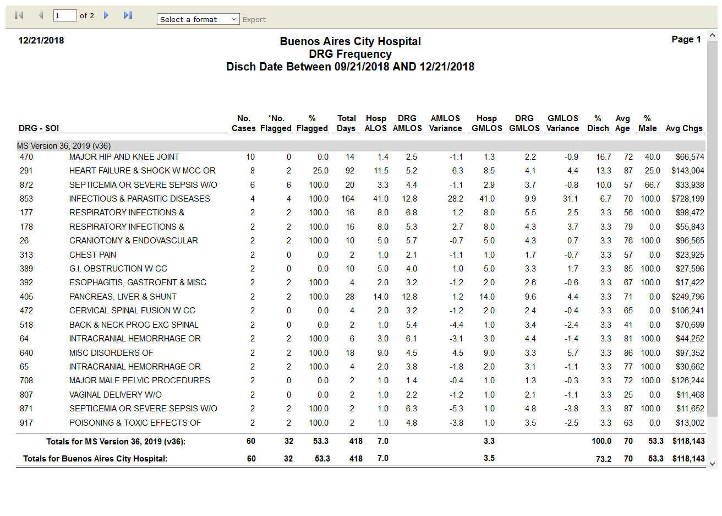

# DRG Illness Severity Score Comparison

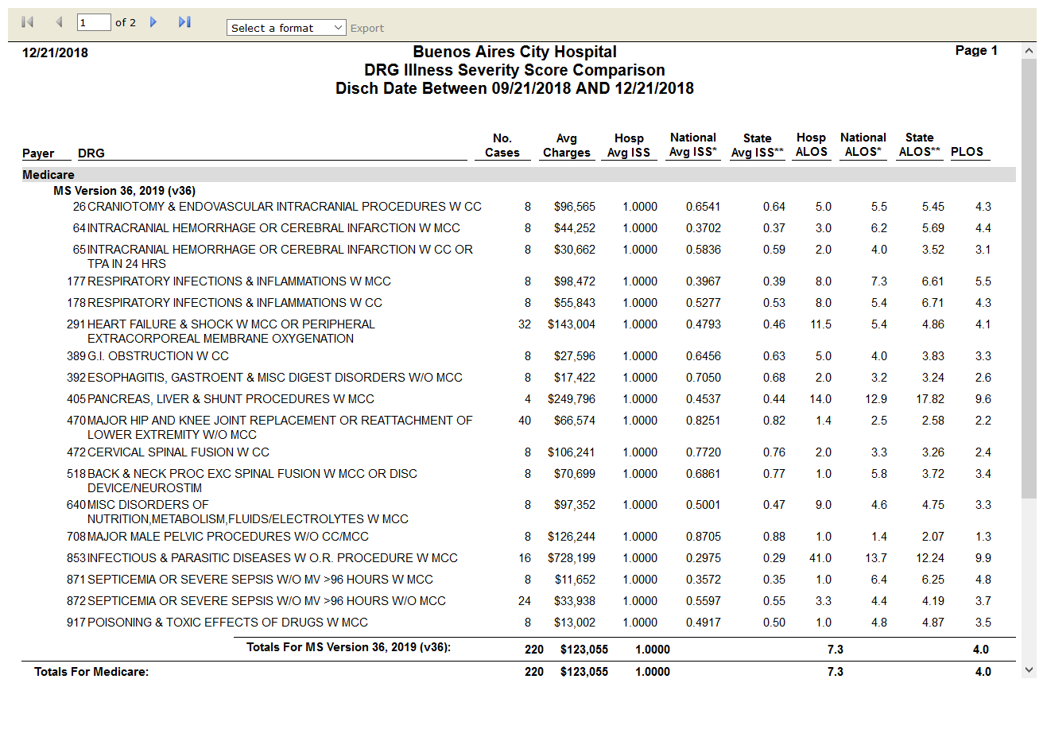

# DRG Summary by Grouper Version - MDC

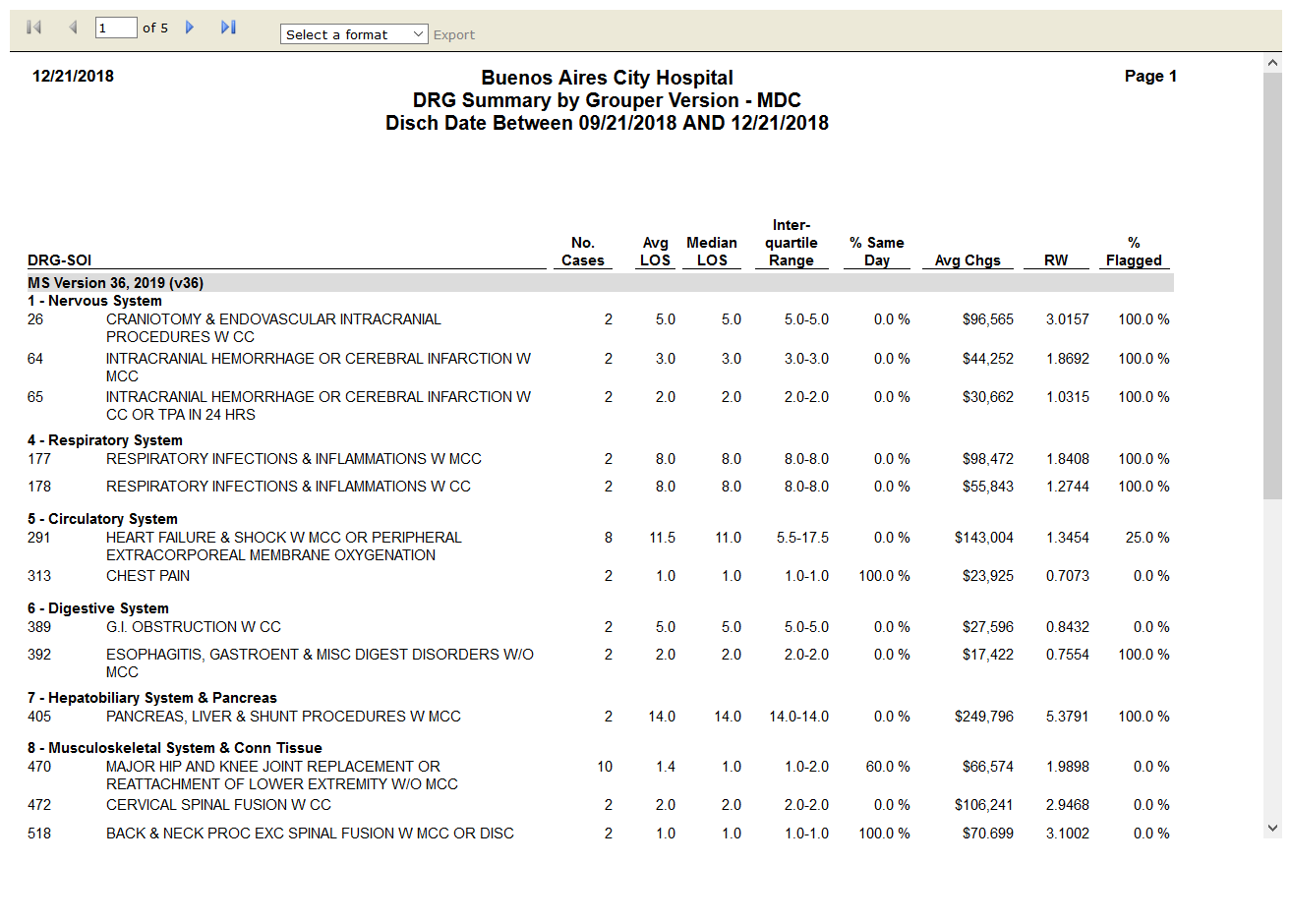

# Average Length of Stay by Payer by Month

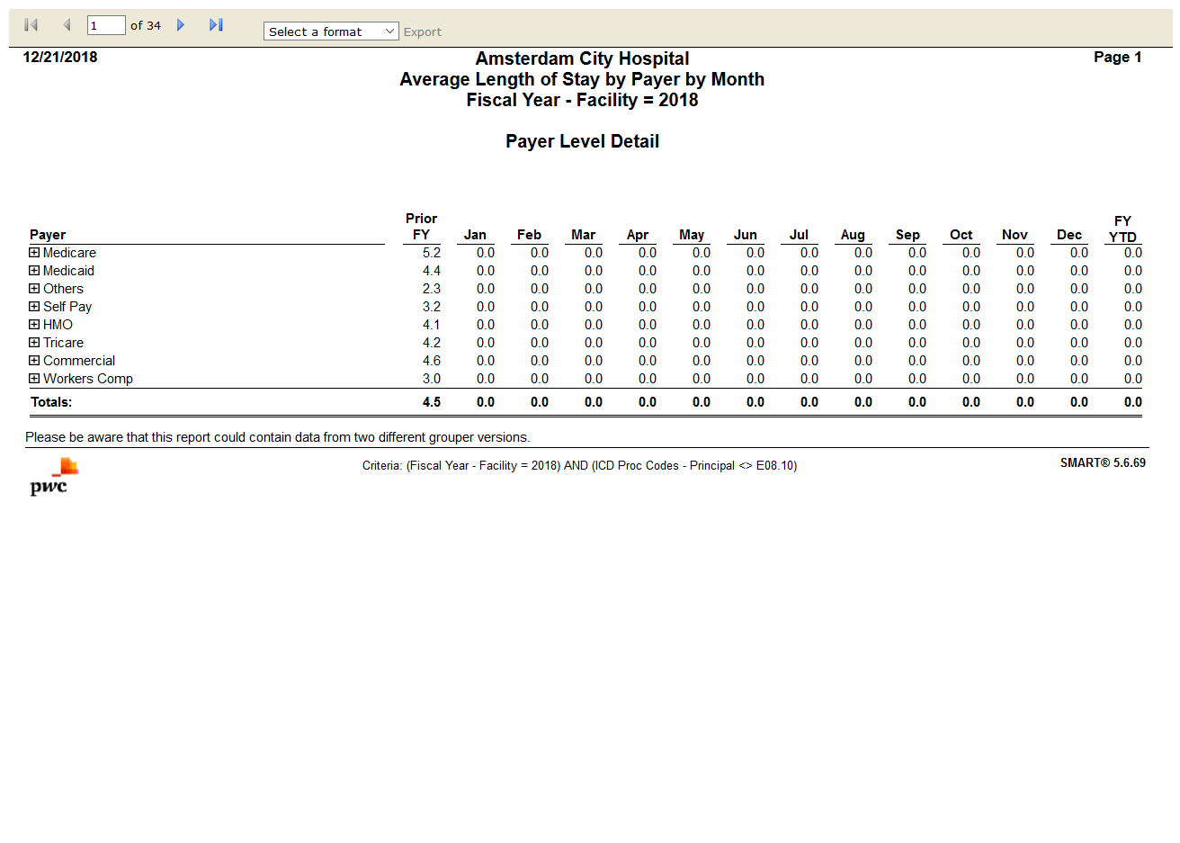

# Illness Severity Score by Payer by Month

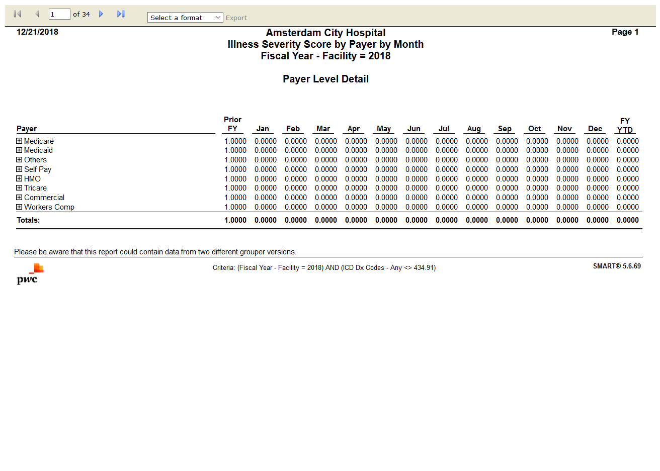

# Diagnosis Analysis by Present on Admission(POA)

# Medicare Hospital-Acquired Conditions

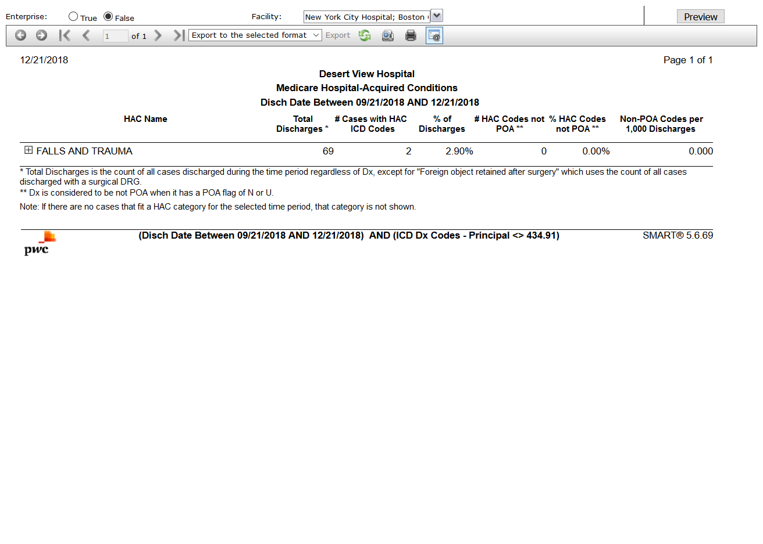

# SMART Reimbursement Activity

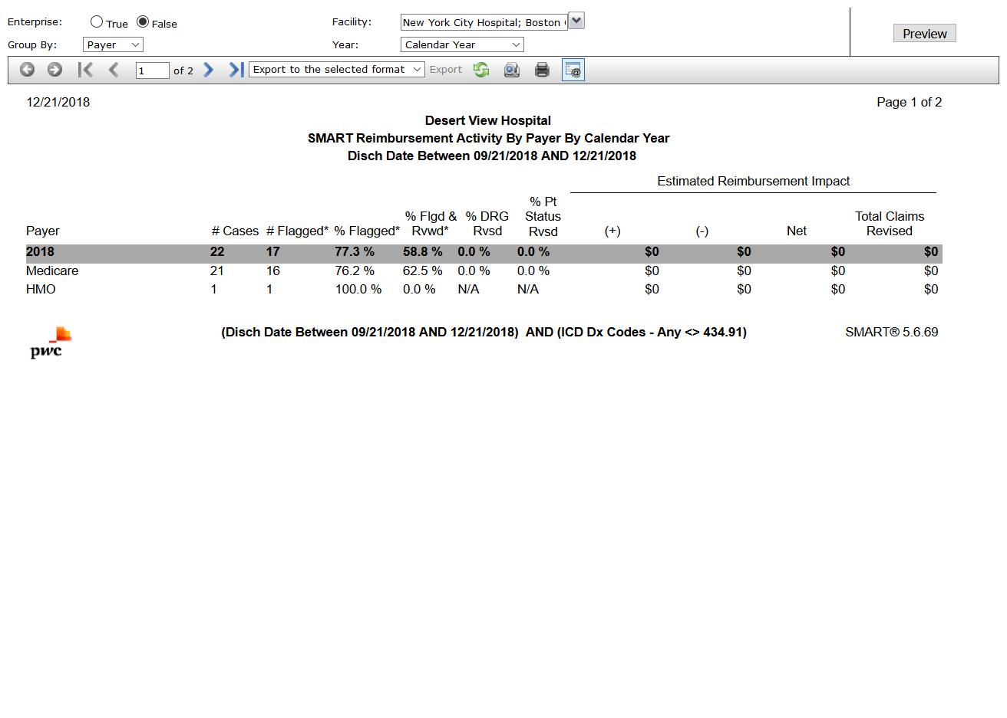

# Medicare Post-Acute Care (PAC) Reimbursement Comparison

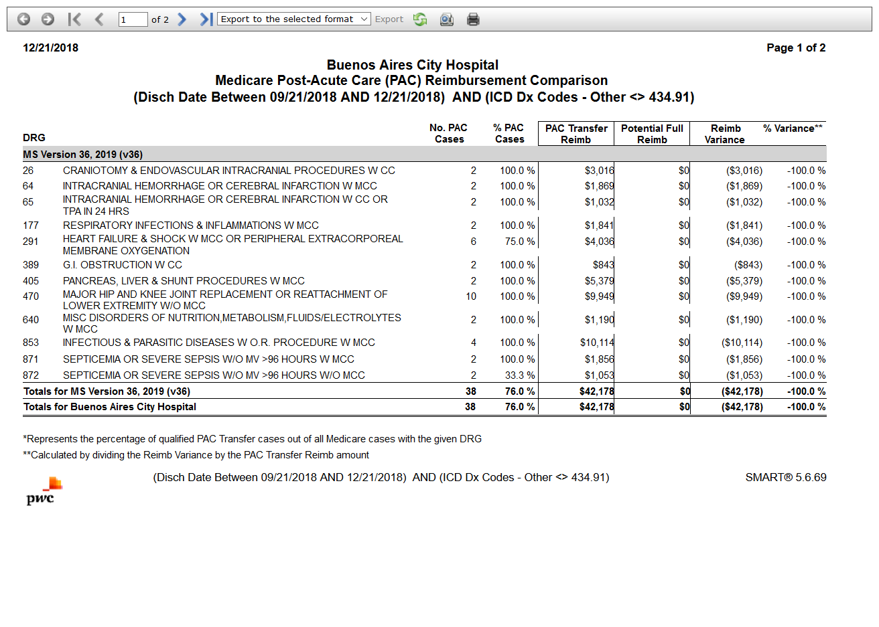

# Medicare Post-Acute Care (PAC) DRG Frequency

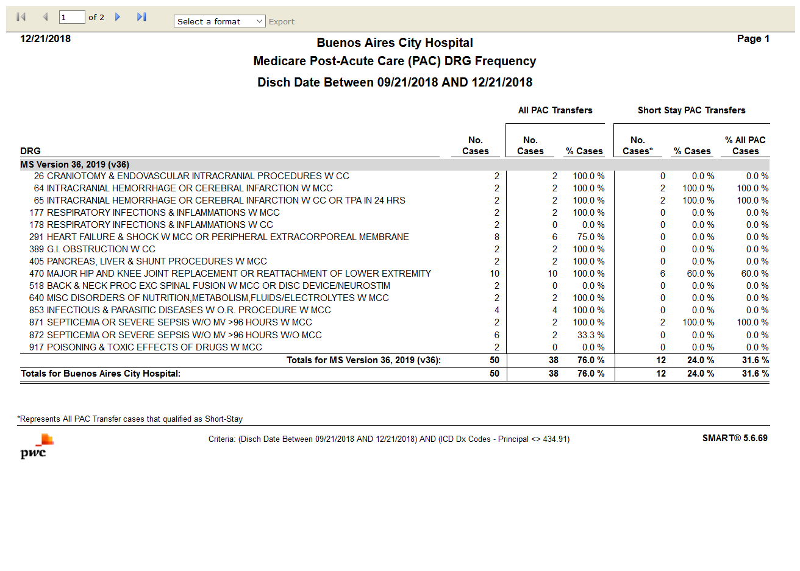

# Performance Metrics

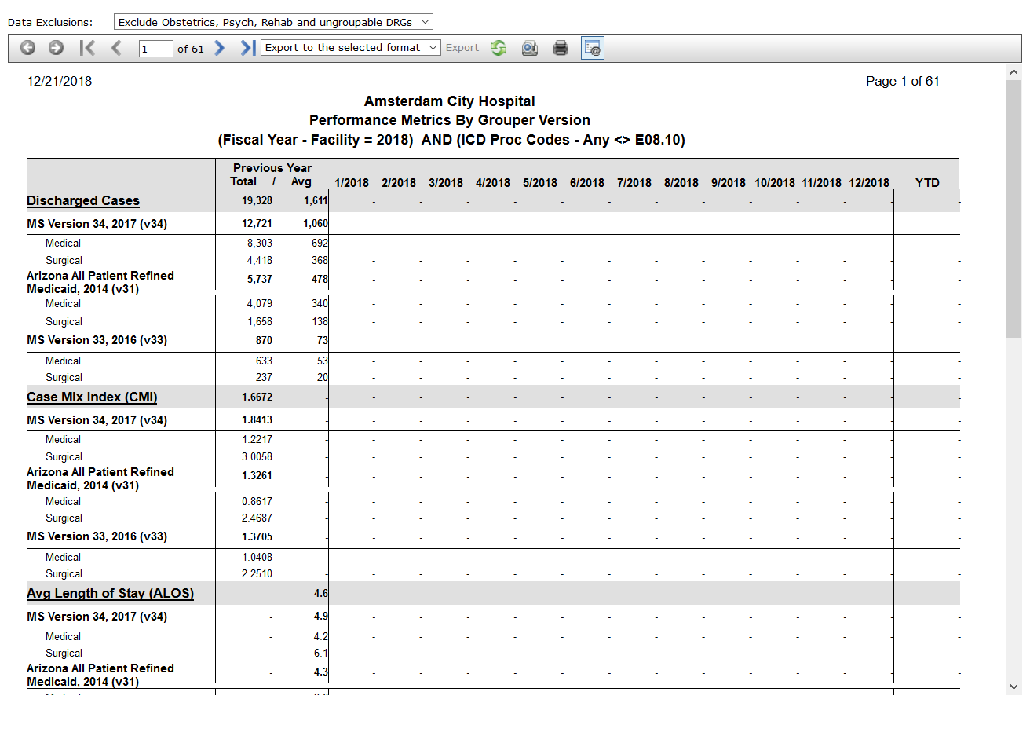

# Present on Admission(POA) Comparison

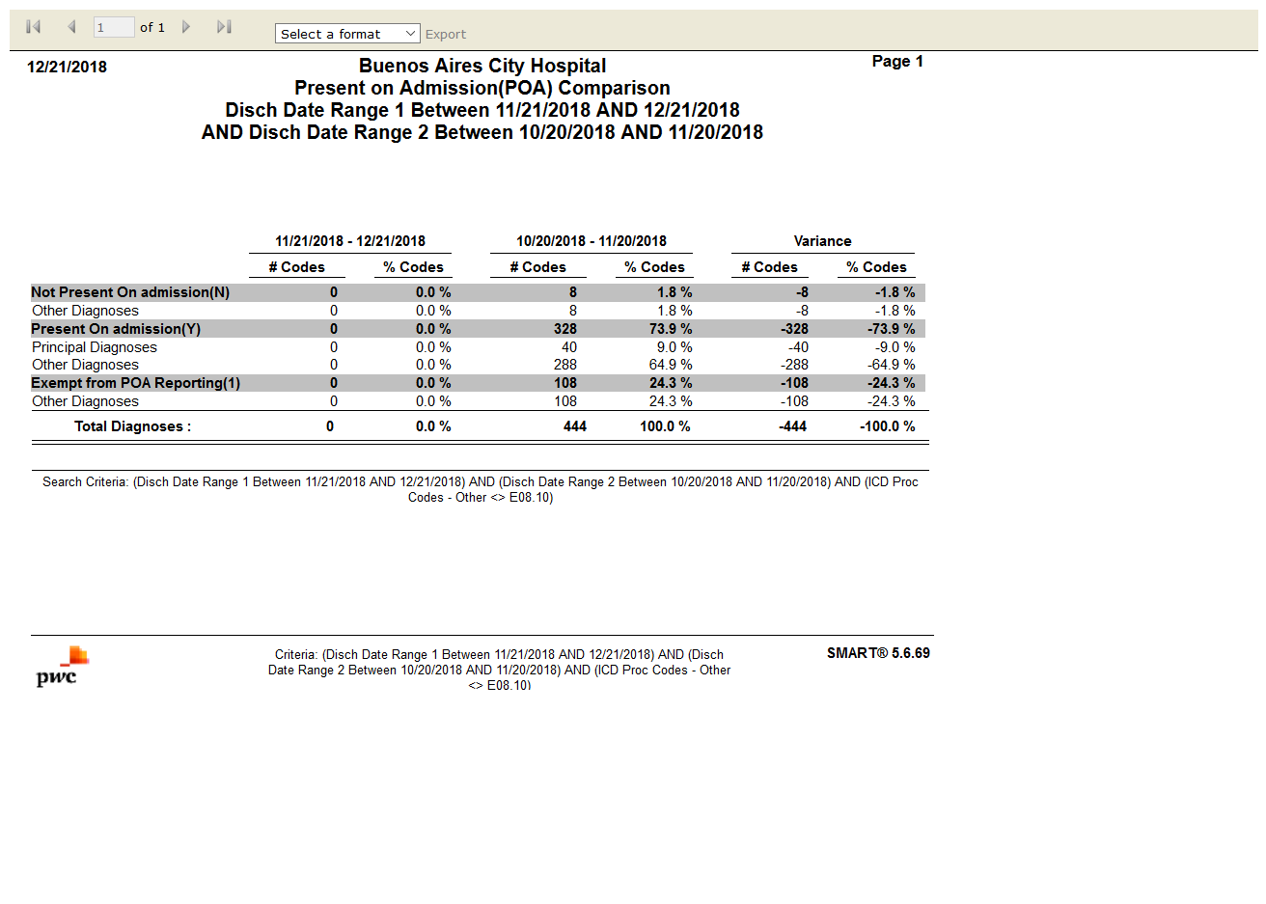

# Principal Procedures

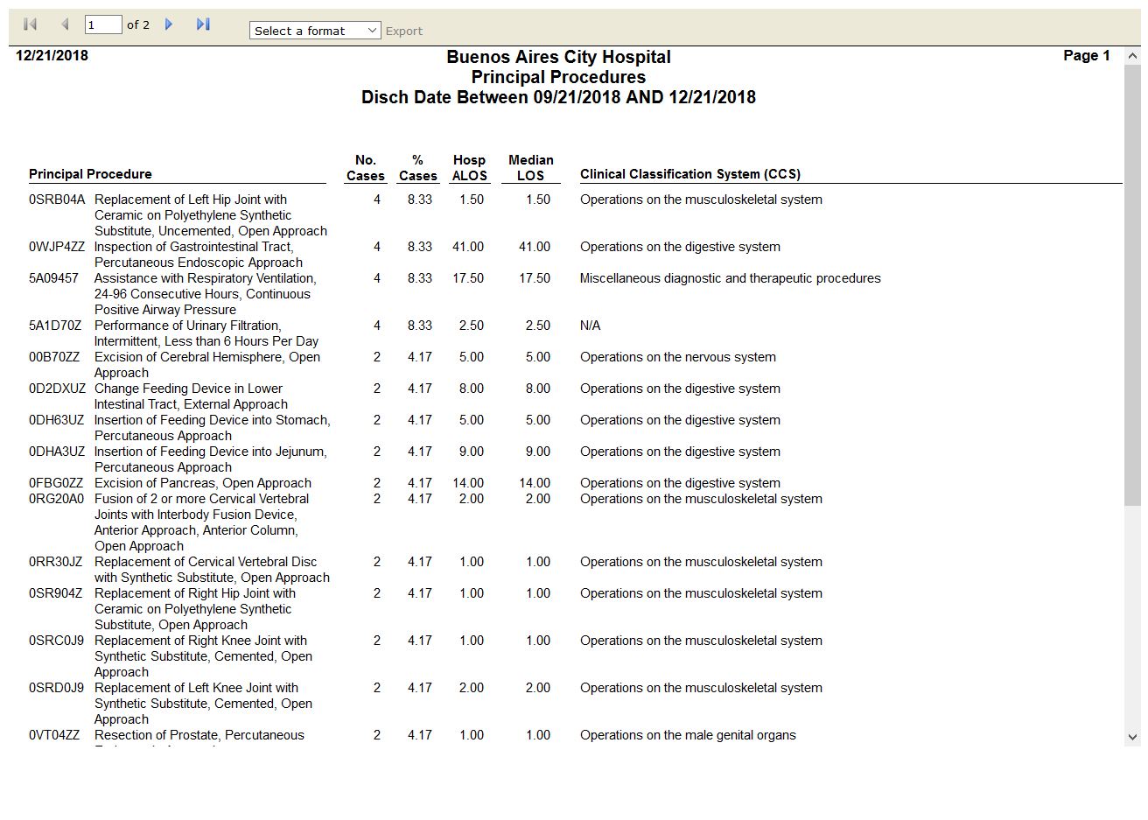

# Profile



# Readmissions

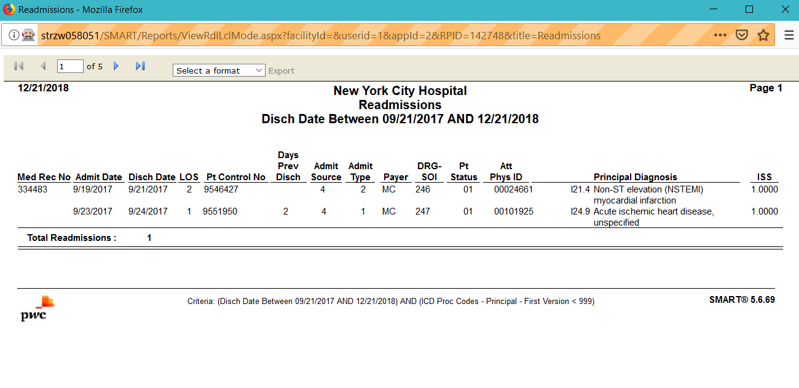

# Case Status Reimbursement Detail

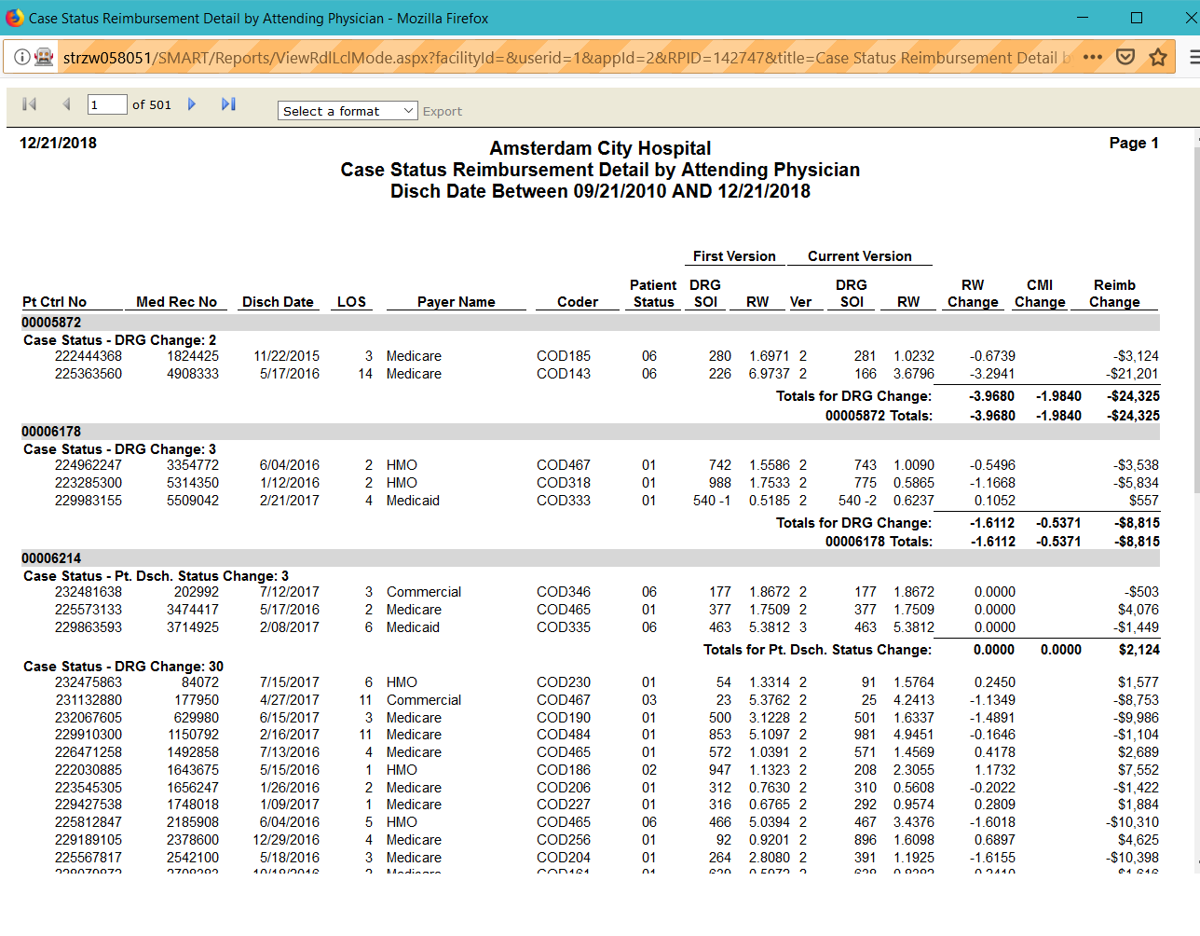

# Grouper Version Reimbursement Detail

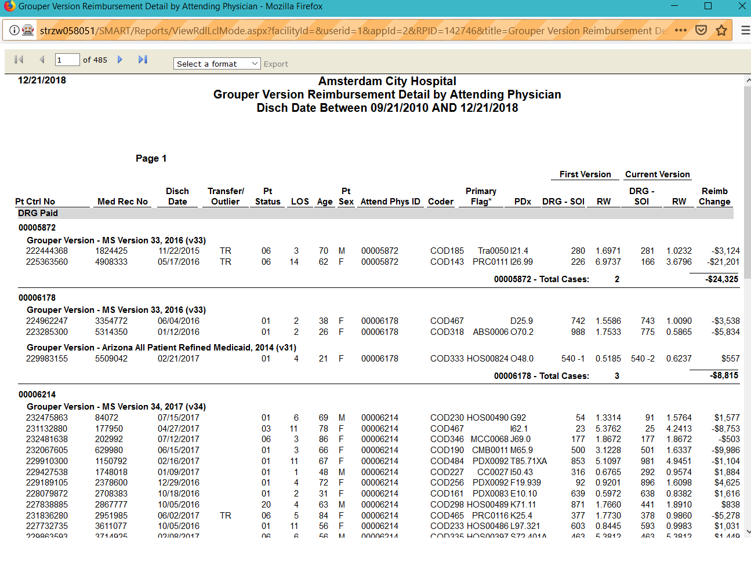

# CMI Reimbursement Summary by Attending Physician

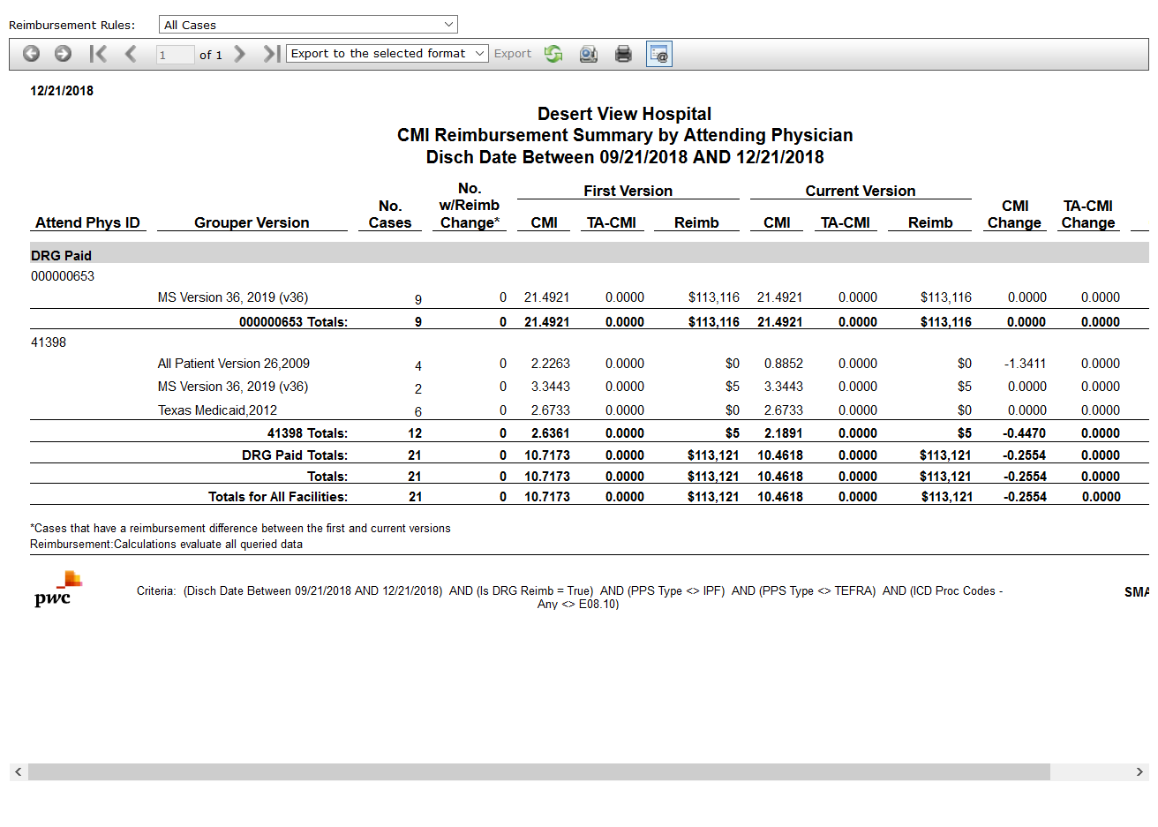

# SMART Case Review Results

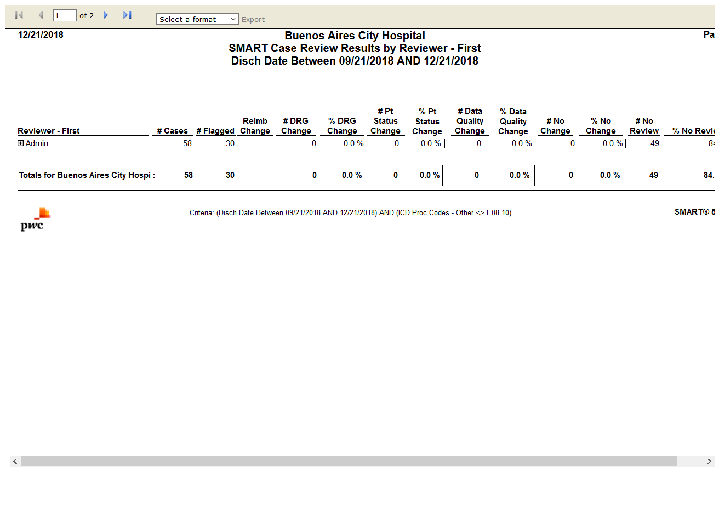

# Case Status Reimbursement Summary

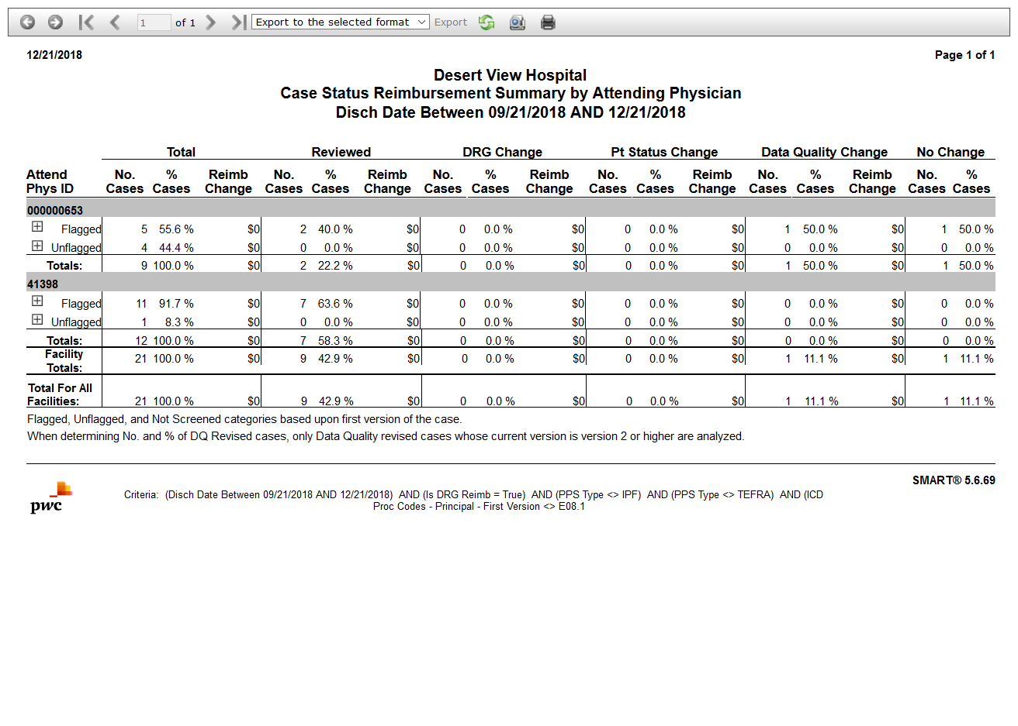

# Reimbursement Change Summary

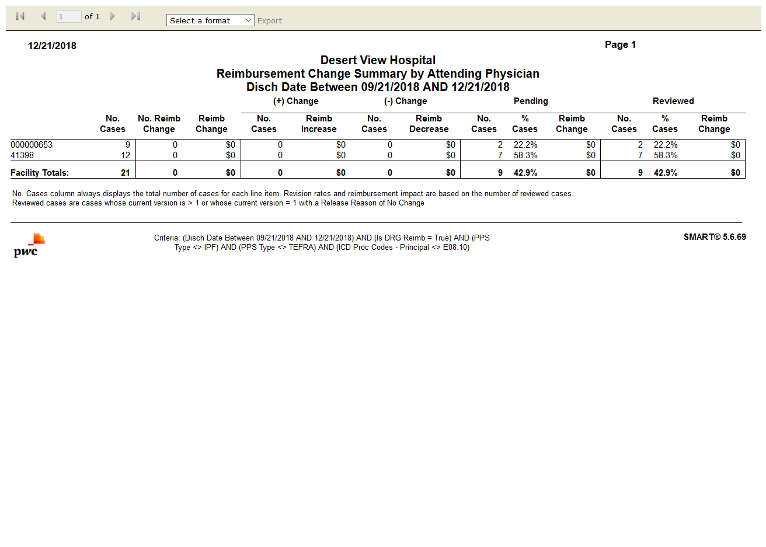

# SMART Report Card

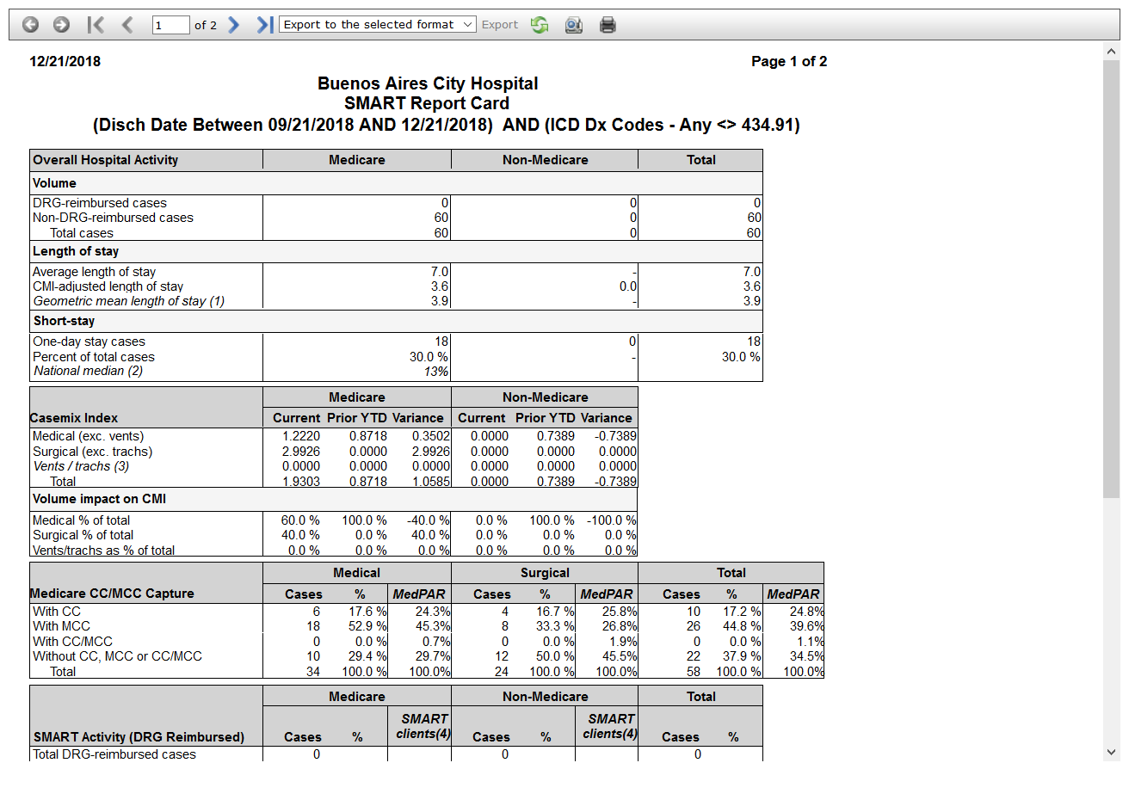

# SMART Reimbursement Activity

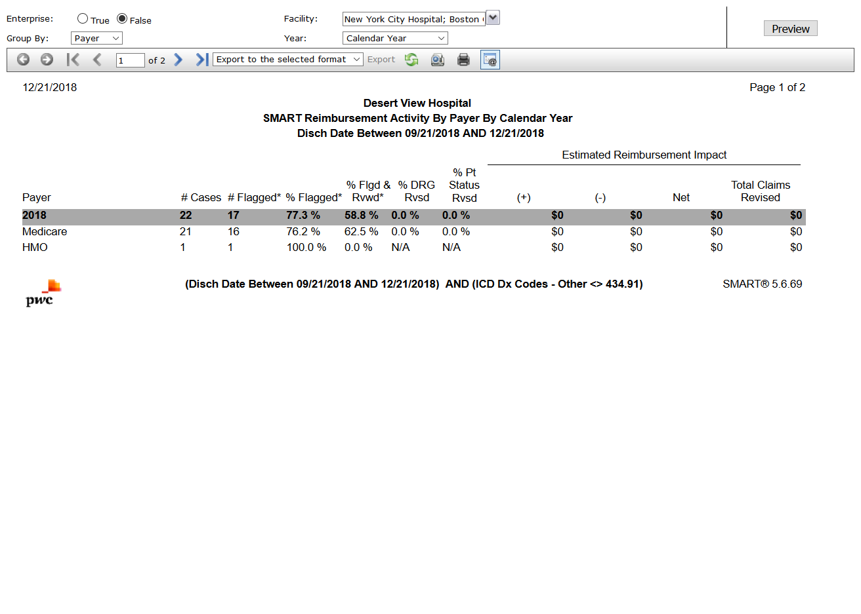

# Summary by Primary Flag

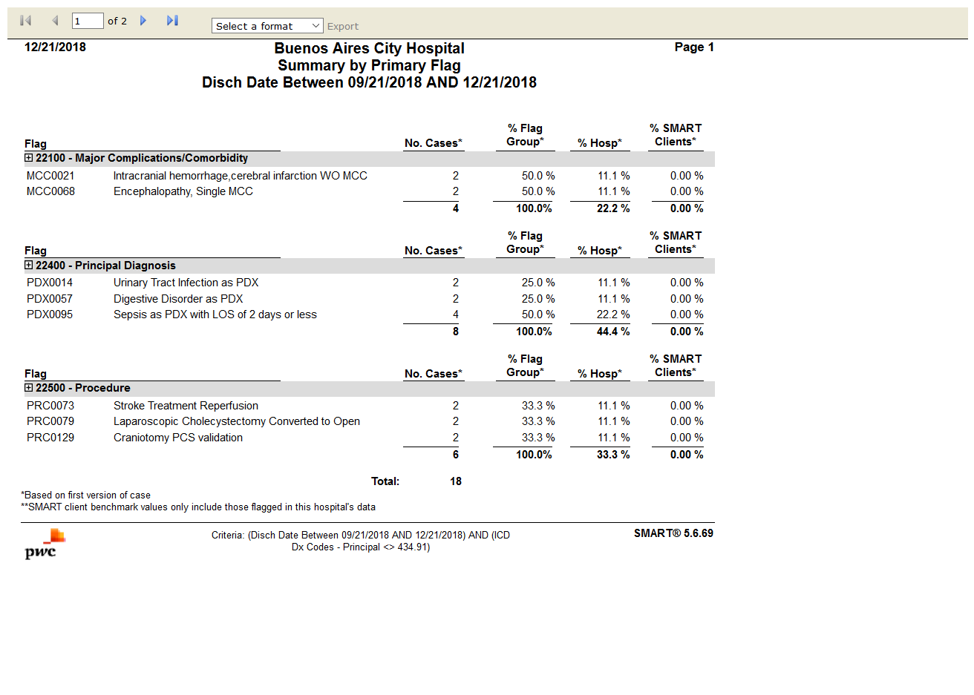

# Top 50 Diagnoses by Present on Admission(POA)

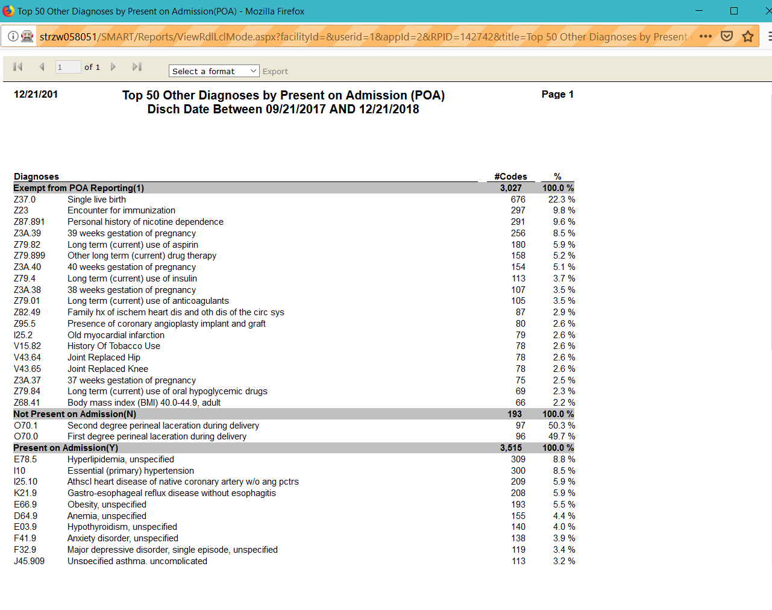

# DRG Illness Severity Score Comparison by Payer

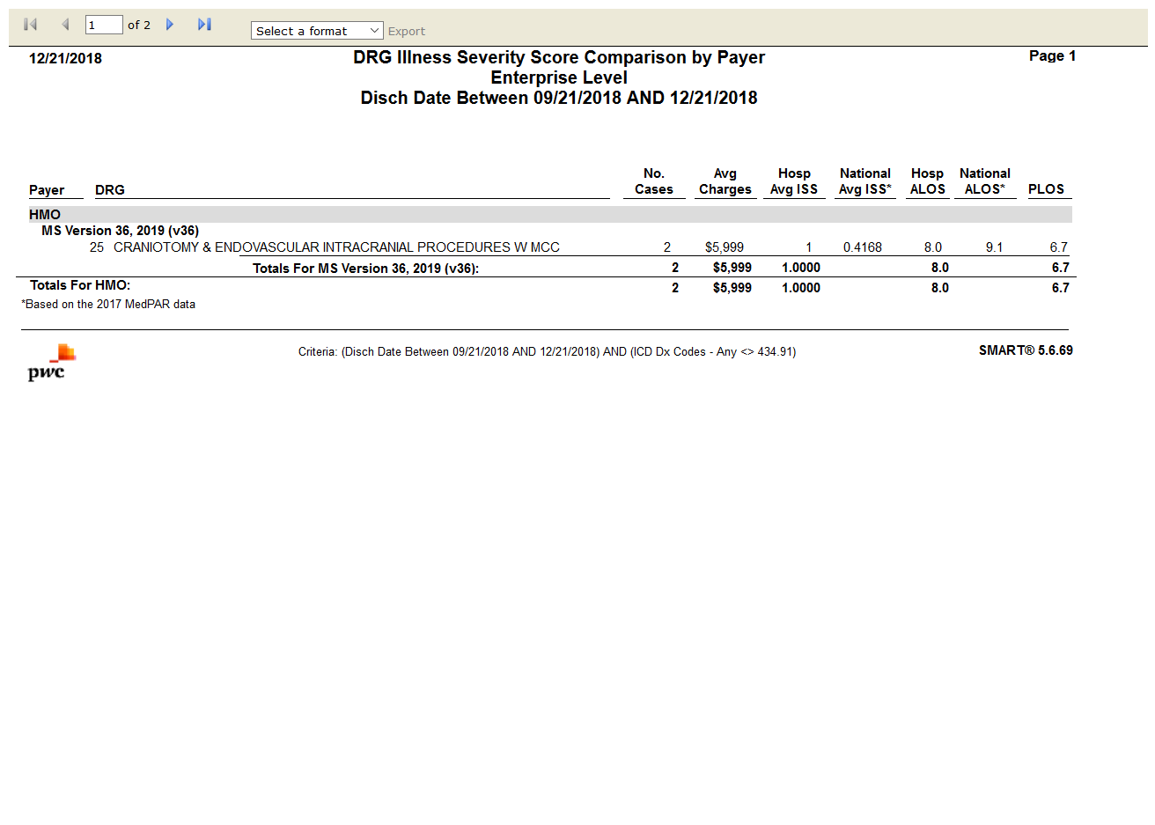

# Medicare Post-Acute Care (PAC) DRG Frequency

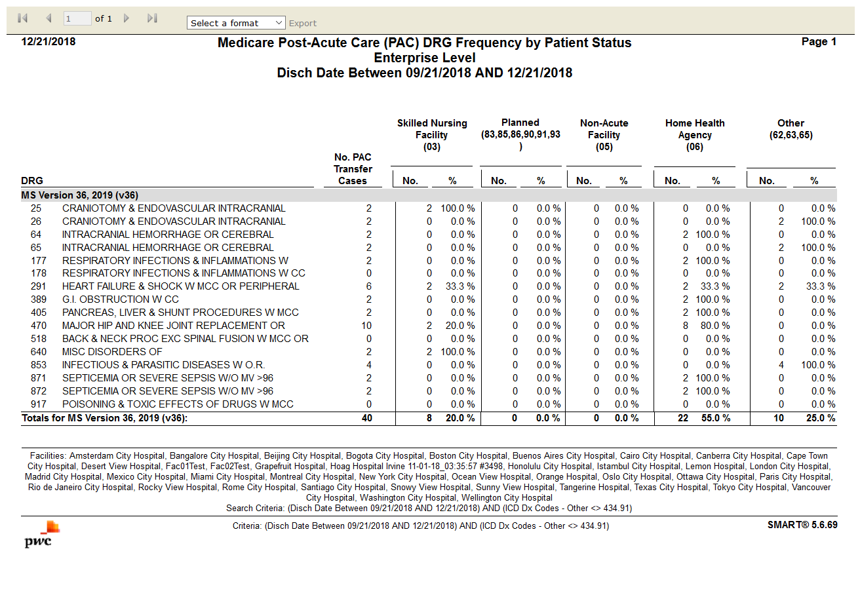

# Frequency

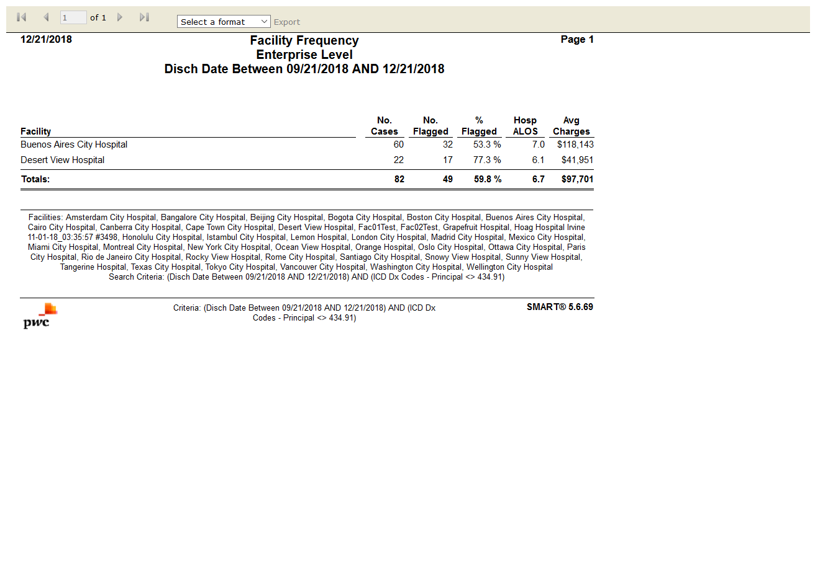

# Case Mix Index (CMI) Comparison

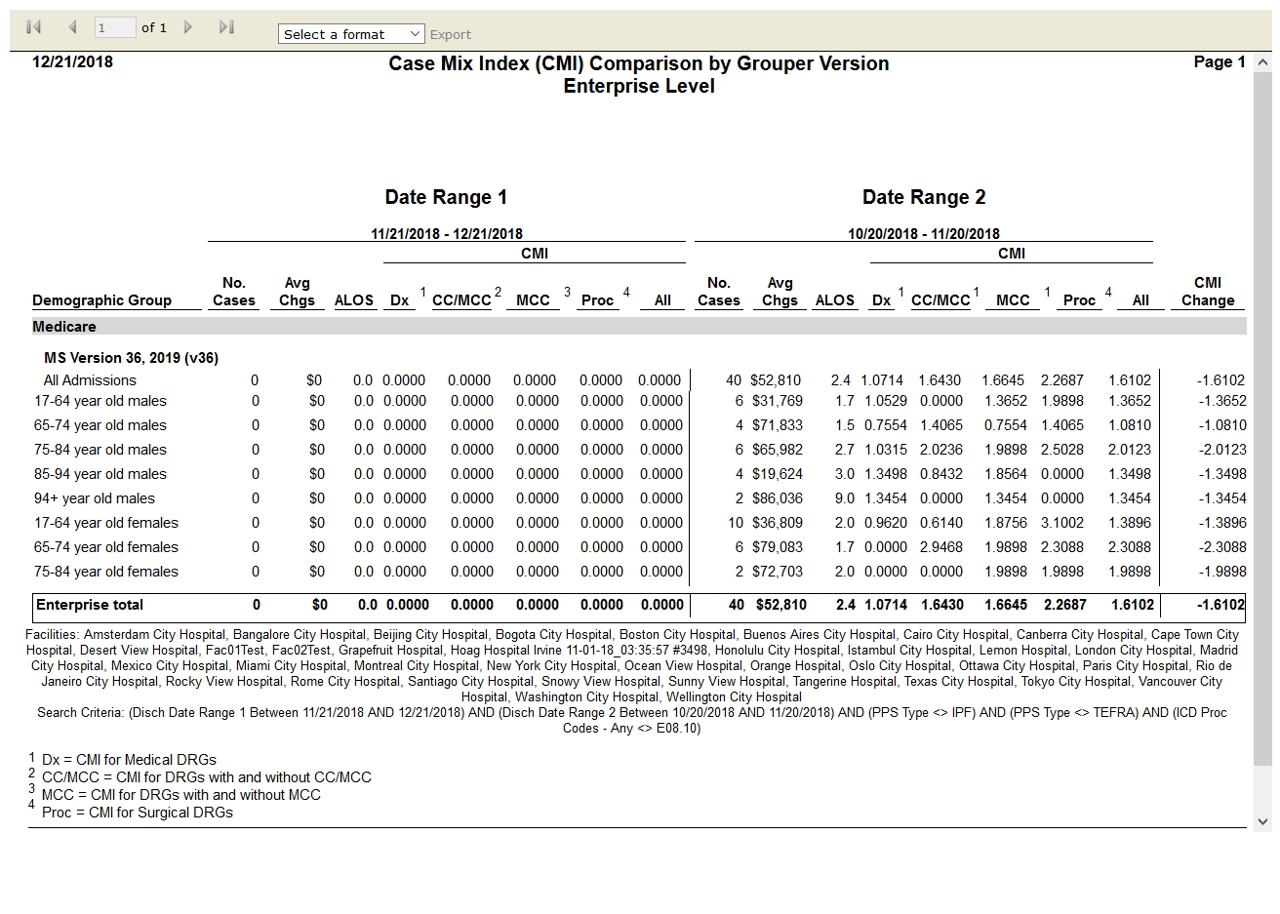

# DRG Frequency

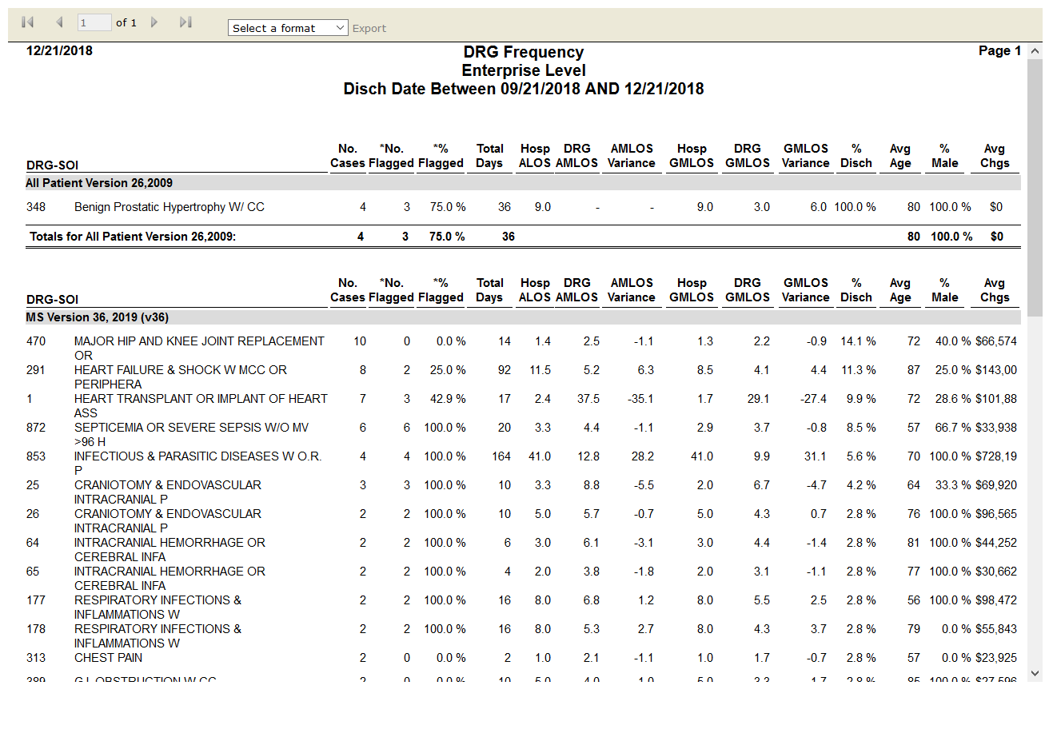

# Reimbursement Change Summary

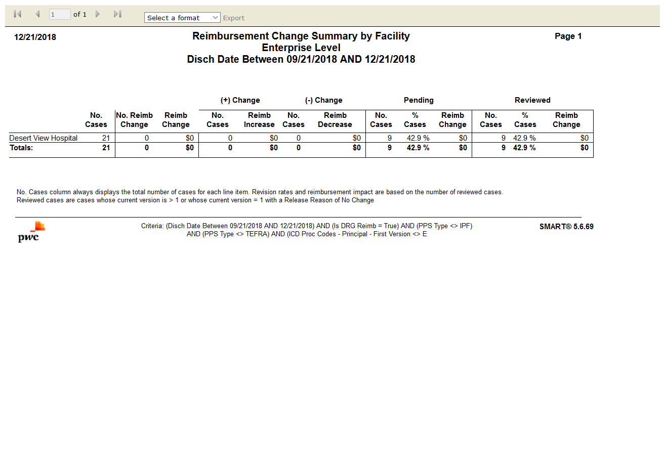

# SMART Results Summary

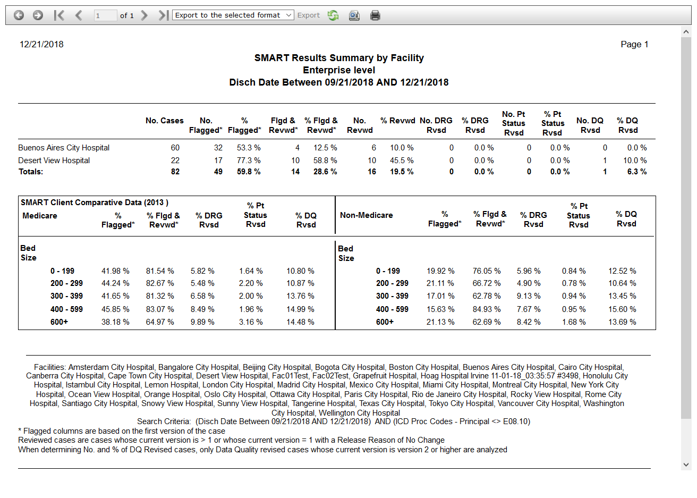

# Flag Rate by Facility by Month

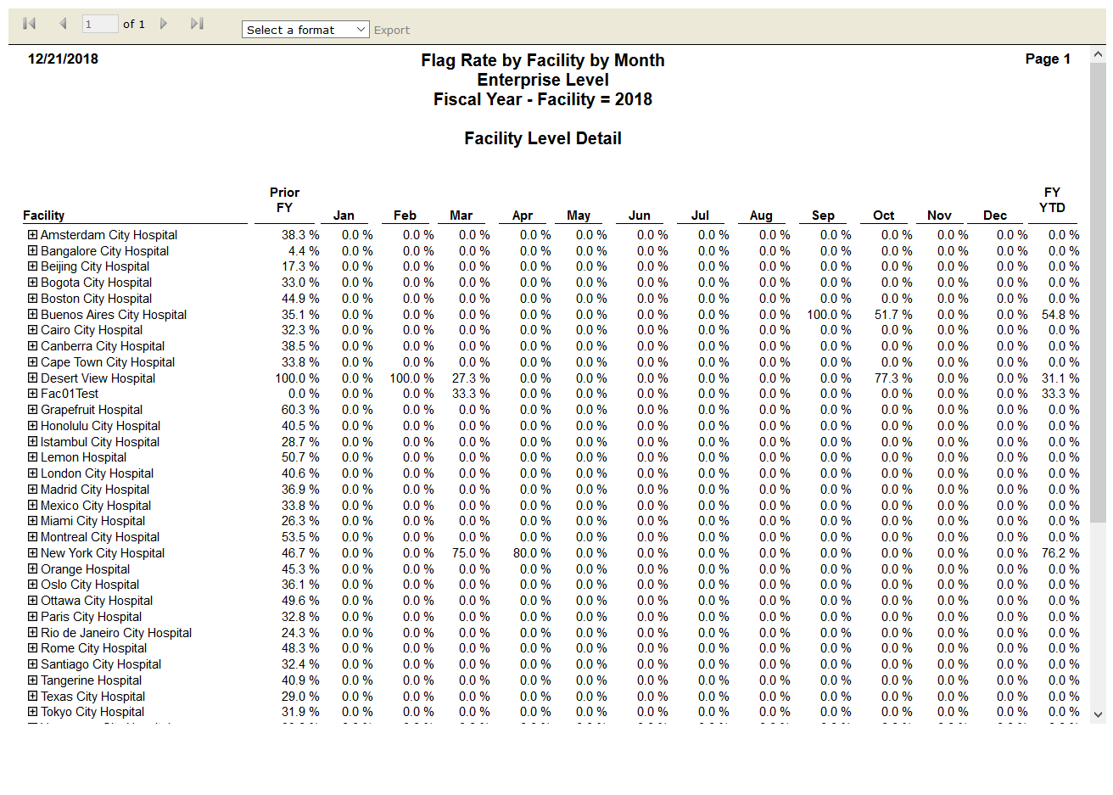

# Medicare HAC Potential Impact

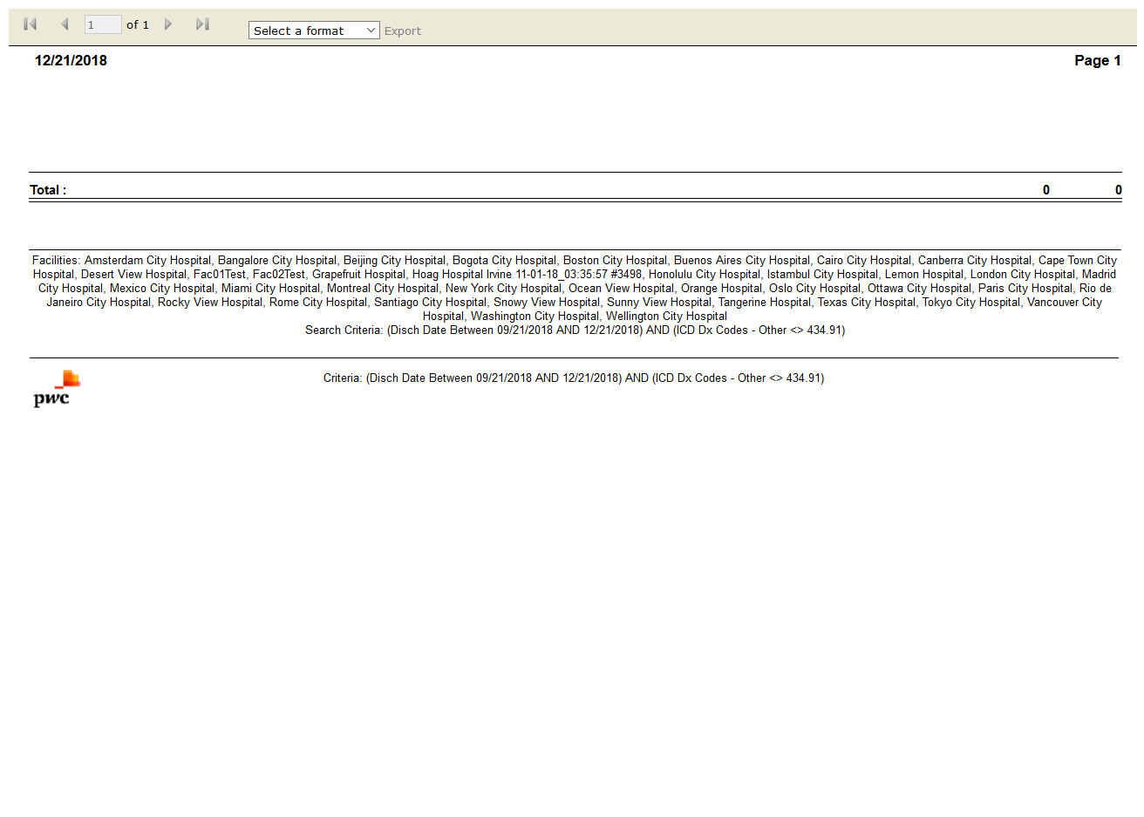

# CMI Reimbursement Summary

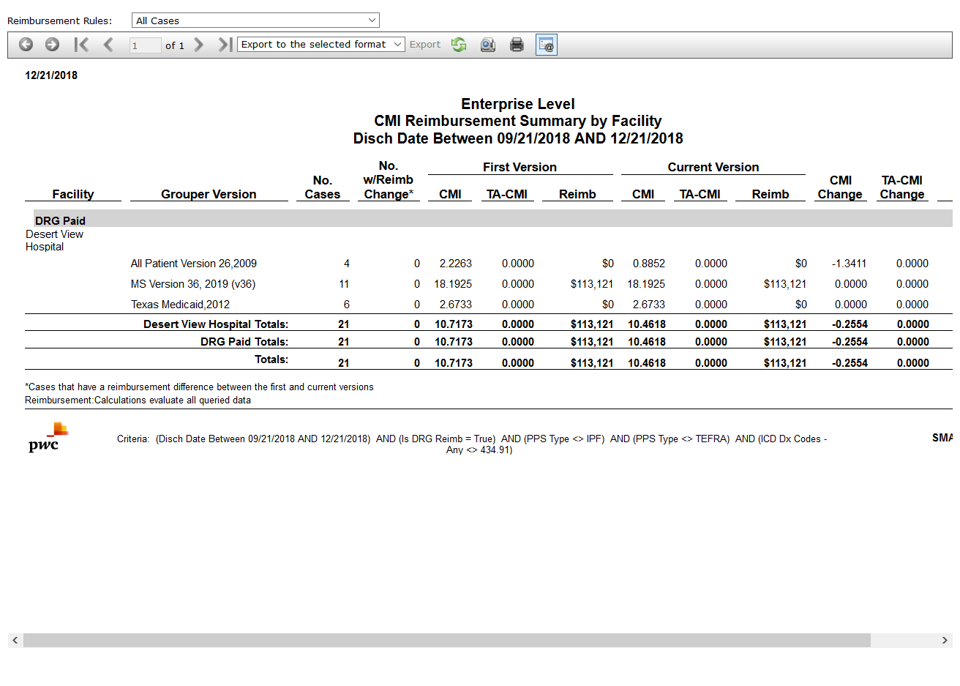

# SMART Case Review Results

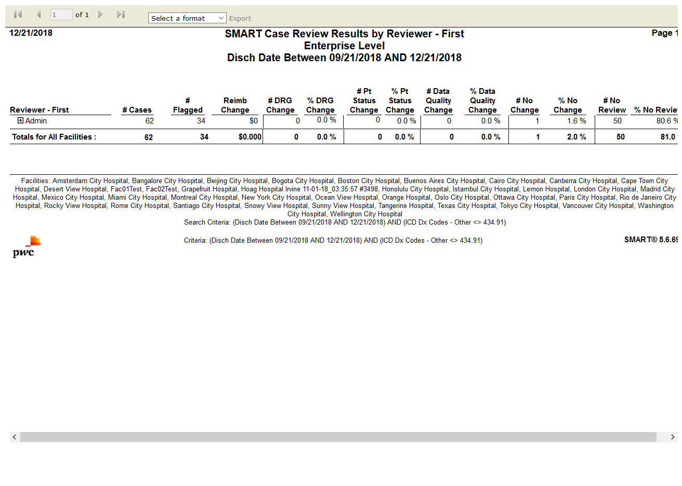

# Summary by Primary Flag with Revision Information

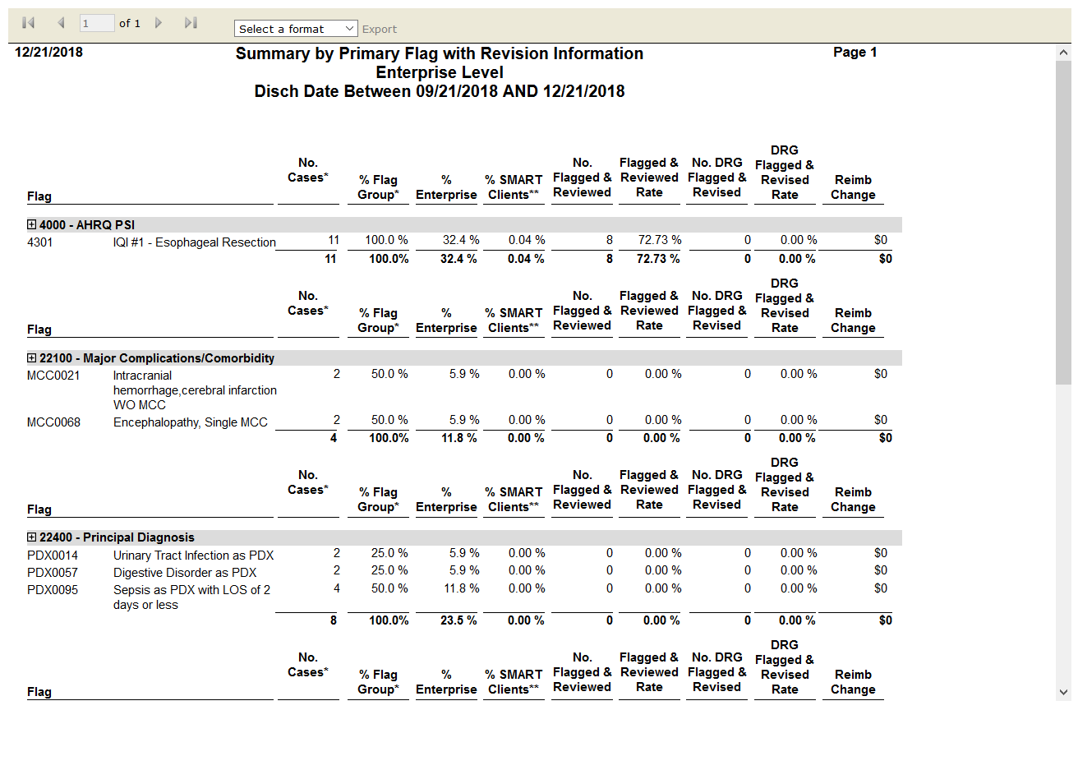

# Top 50 CC/MCC Diagnoses

